Technical Manual
BPKZ_BAN_DEREG
The BPKZ_BAN_DEREG Package has the following files:
1. Package Files:
BPZ_BAN_DEREG (Package specification)
BPZ_BAN_DEREG_body (It contains the definitions of cursor and subprograms declared in the package specifications).
2. Additional Requirement:
BAN_DEREG.shl Shell Script.

Adding BPKZ_BAN_DEREG in Objects
In order to make this package functional first we have to add the object in Banner Access Management (BAM), for this purpose you have login into BAM.
After logging in, you can navigate the BAM tool by using the hamburger menu located at the upper left-hand corner of the screen. Clicking on this icon will display a list of pages that you can access, you need to access the 'Oracle/Banner Security Maintenance' feature.

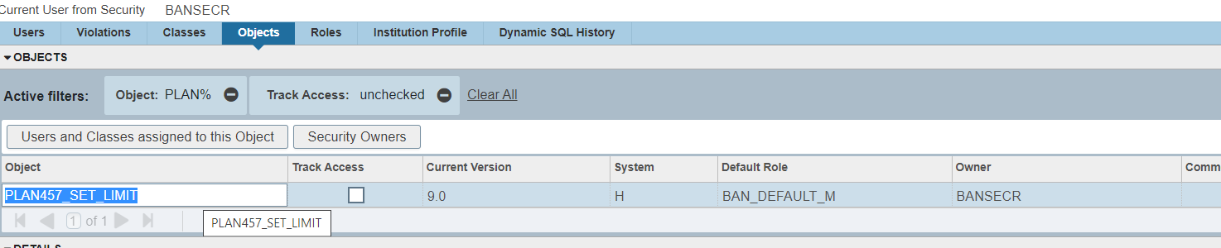
- Open the Object tab and select Insert to create a new record.
- Enter the name of the object as BPKZ_BAN_DEREG and specify the version of the package as 0.1 (since it is the first created version).
- Select System as R since this package is for Registrar Office.
- Choose the default role as BAN_DEFAUT_M.
- Determine the appropriate owner for the object based on who requires access to it. In this case, I have assigned the owner as BANSECR since only a few people have access to it.
- Finally, click on the SAVE button to create and save the object.

Giving Access to BPKZ_BAN_DEREG other users
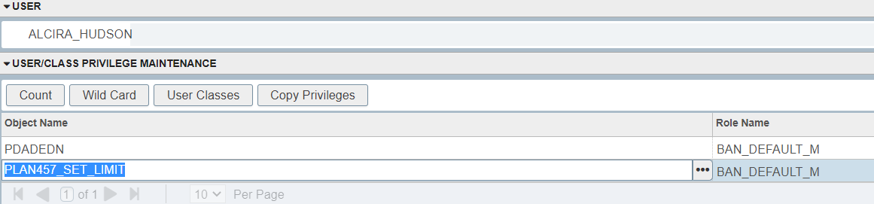
- Click on USER and enter the User ID (name ID) of the user you want to modify.
- Click on Modify to open the user's details page.
- On the new page, create a new record by entering BPKZ_BAN_DEREG in the appropriate field.
- Click on SAVE to grant access to the user for BPKZ_BAN_DEREG.

SETTING UP BPKZ_BAN_DEREG PROCESS
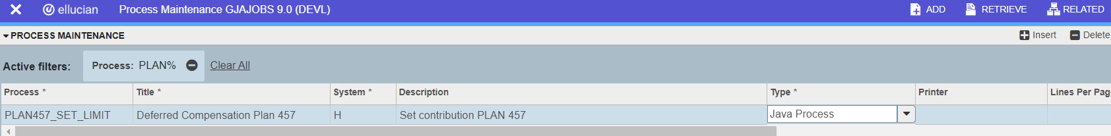
- Access to App Nav (Banner) in the landing Page type in "GJAJOBS" and press enter
- Once the GJAJOBS page loads, click on "Insert", in the new row type BPKZ_BAN_DEREG as you see above.
- Enter the title of the process as shown above
- Under "System," enter "R" for Registrar Office
- Add a brief description for the process
- Under "Type," select "Java Process"
- Click "Save" to save your changes.

Move the shell file to the appropriate directory for shell files (/banner/esc/banPROD/links)
- Navigate to the directory where the file BAN_DEREG.shl is located using the cd command:
cd /banner/sicas/
- Copy the file to the directory /banner/ESC/banprod/links/ using the cp command:
cp BAN_DEREG.shl /banner/ESC/banprod/links/
With these instructions, you should be able to place the BAN_DEREG.shl file in the correct directory, copy it to /banner/ESC/banprod/links.

Adding the parameters for BPKZ_BAN_DEREG in GJAPDEF
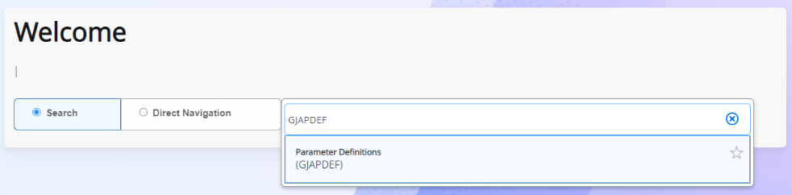
Once you have navigated to the GJAPDEF page, enter BPKZ_BAN_DEREG in the box. Afterward, click on the Go button and begin entering the remaining parameters. This page consists of six parameters, so ensure that you input them exactly as they are shown below to avoid errors.
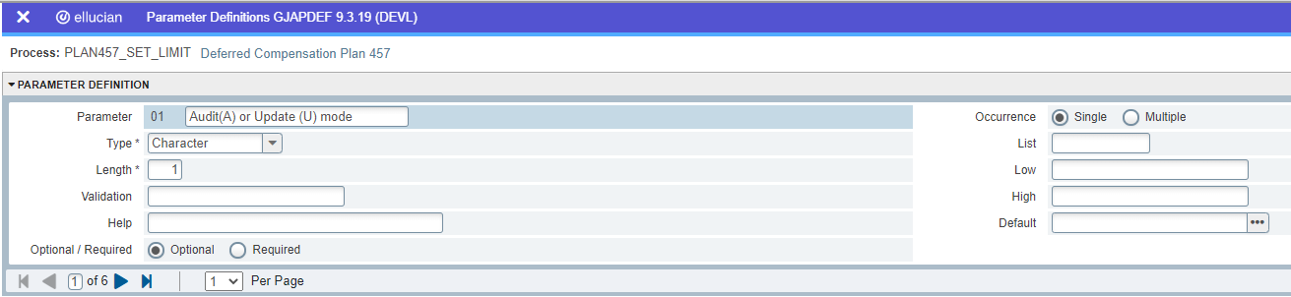

Once you have entered all the parameters, click 'Save' and the package will be ready to use in Banner.

